CS 255 Business Requirements Document
Jessica Paul

Complete this template by replacing the bracketed text with the relevant information.

This template lays out all the different sections that you need to complete for Project One. Each section has guiding questions to prompt your thinking. These questions are meant to guide your initial responses to each area. You are encouraged to go beyond these questions using what you have learned in your readings. You will need to continually reference the interview transcript as you work to make sure that you are addressing your client’s needs. There is no required length for the final document. Instead, the goal is to complete each section based on your client’s needs.

Tip: You should respond in a bulleted list for each section. This will make your thoughts easier to reference when you move into the design phase for Project Two. One starter bullet has been provided for you in each section, but you will need to add more.

System Components and Design

Purpose
What is the purpose of this project? Who is the client and what do they want their system to be able to do?
- The purpose of the program desired by DriverPass is to help their customers pass driving tests at the DMV. They want to provide training with practice exams, classes, and on-the-road training to help increase the statistics of their customers passing driving exams. They want to build a system to handle this.

System Background
What does DriverPass want the system to do? What is the problem they want to fix? What are the different components needed for this system?
- The system should provide driving data on its customers that can be accessed online and downloaded as an excel spreadsheet. Users should be able to track their progress and schedule reservations for driving lessons. We need to handle security for user accounts, create databases to store user information and reservations, the ability to add and drop packages offered by the company to its users, the ability to take a practice test or classes online, and to create an interface for end users to interact with.

Objectives and Goals
What should this system be able to do when it is completed? What measurable tasks need to be included in the system design to achieve this?
- We should measure whether a user can create an account and save information to a database, whether a user can schedule a reservation and track it in the system, whether the customers can take tests, whether those tests are being properly tracked, and whether customers can see and but different packages.

Requirements

Nonfunctional Requirements
In this section, you will detail the different nonfunctional requirements for the DriverPass system. You will need to think about the different things that the system needs to function properly.

Performance Requirements
What environments (web-based, application, etc.) does this system need to run in? How fast should the system run? How often should the system be updated?
- DriverPass wants the system to be a web-based system that runs off a cloud based server. The system needs to be quick enough to handle normal business use by the customers without excessive wait times. Customers should be able to take tests, lessons, etc… without long delays. The system will need to be updated whenever there are new DMV rules, lesson content changes, or bugs need to be fixed. We should implement a way to allow DriverPass to update lesson content, scheduling, and related fields themselves without needing us to intervene.

Platform Constraints
What platforms (Windows, Unix, etc.) should the system run on? Does the back end require any tools, such as a database, to support this application?
- The system should run on a cloud based server accessible by any internet browser on any system. We would need a backend database that stores user information and data, schedules and lessons, packages, and any other content necessary for the application. It would also need to manage user accounts with various roles and verifications.

Accuracy and Precision
How will you distinguish between different users? Is the input case-sensitive? When should the system inform the admin of a problem?
- Different users should be able to create different accounts with different usernames and passwords. The credentials should be case sensitive for additional security. Different users should have different roles attached to their accounts so that users are only able to access the information they need. Only DriverPass staff should be able to modify users and content. Admins should be notified of problems such as security issues, problems with data, and system performance issues.

Adaptability
Can you make changes to the user (add/remove/modify) without changing code? How will the system adapt to platform updates? What type of access does the IT admin need?
- DriverPass should and can have the ability to modify users and content on the system without altering the code. Running the system over cloud means that we can have it pull data from an external source to modify content and give certain roles the ability to modify accounts. We can give the IT admin access to all accounts and content so that they can make these modifications themselves.

Security
What is required for the user to log in? How can you secure the connection or the data exchange between the client and the server? What should happen to the account if there is a “brute force” hacking attempt? What happens if the user forgets their password?
- For a user to log in, they will need a username and password. We should use secure login handling, role-based access and add protection to sensitive customer information. If there is a “brute force” hacking attempt, we should have security checks in place to block user access after a certain number of failed attempts and alert the IT admin. If a user forgets their password, there needs to be a way in place to reset the password to something new.

Functional Requirements
Using the information from the scenario, think about the different functions the system needs to provide. Each of your bullets should start with “The system shall . . .” For example, one functional requirement might be, “The system shall validate user credentials when logging in.”
- The system shall schedule lessons with instructors for users at the user’s request
- The system shall store user data and progress
- The system shall allow admins to manage content and users
- The system shall allow users to take lessons and practice exams

User Interface
What are the needs of the interface? Who are the different users for this interface? What will each user need to be able to do through the interface? How will the user interact with the interface (mobile, browser, etc.)?
- The interface should display areas for users to see progress and information, schedule driving lessons, take lessons and practice exams, contact the company, and a place for admins specifically to see and modify users. There should be roles including the owner, IT admin, secretary, and customer. The owner should be able to monitor every aspect of the system and have access to various reports and. The IT admin should be able to view and modify users and needs full access to maintain the system. The secretary needs to be able to add user appointments and schedules and should be able to see user information about customers who call. The regular user should be able to schedule appointments, track their progress, and take lessons and practice exams. The users will access the system through any device with an internet browser.

Assumptions
What things were not specifically addressed in your design above? What assumptions are you making in your design about the users or the technology they have?
- There are several things not specifically addressed in the design above. These include types of internet browsers and their compatibility, the specific coding language, how payment is going to work, how the IT admin and owner should be notified when needed, and the layout of the site beyond the rough sketch. Some assumptions include users having internet access, users having a device that has an internet browser, that the customers have enough technical knowledge to use the system, and that the system will be maintained to match DMV standards.

Limitations
Any system you build will naturally have limitations. What limitations do you see in your system design? What limitations do you have as far as resources, time, budget, or technology?
- One limitation is the fact that there are many features requested for an initial release within a small frame of time to get them added. We may have cut some less crucial aspects to get all the features and come back in and add them later. The team itself has a small number of people managing many tasks. There may not be enough staff within DriverPass to handle the system on top of the responsibilities they already have. On top of this, DriverPass may need a higher budget than what they had planned to get all the features in and maintain the system after.

Gantt Chart
Please include a screenshot of the GANTT chart that you created with Lucidchart. Be sure to check that it meets the plan described by the characters in the interview.

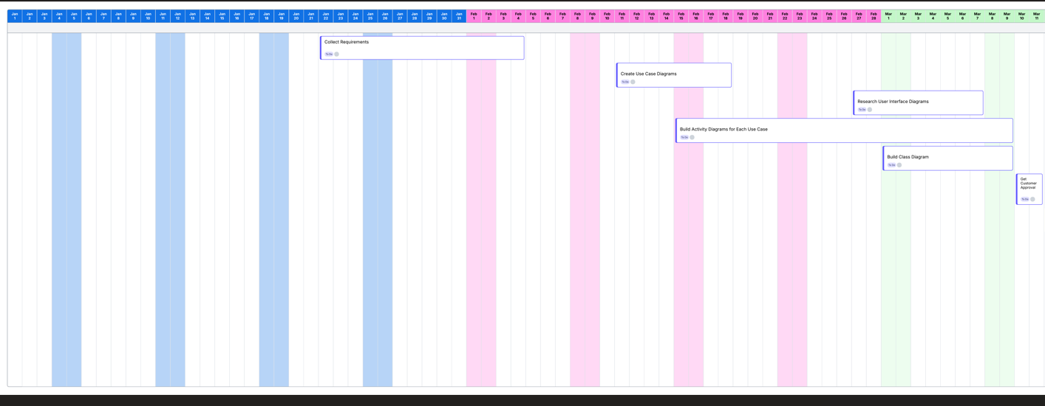
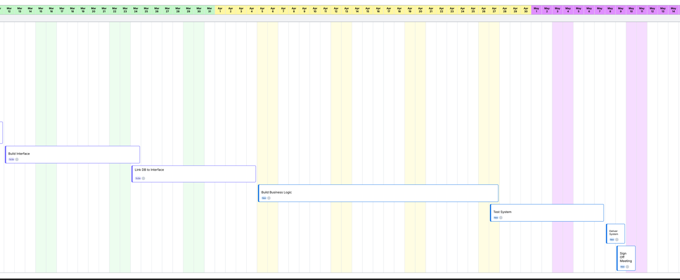
(I broke this into two screenshots so it could be read)

